1. LG CL98 XBOOM 3500W HI-FI

* [LG](https://www.takealot.com/tv-audio-video/lgstore?utm_source=brand_links)

CL98.DZAFLLK

Be the first to [write a review](https://www.takealot.com/lg-cl98-xboom-3500w-hi-fi/PLID66650923/reviews/1/write).

**ONLY 6 LEFT AT**

**R 10,379**

**FREE DELIVERY**

eB103,790

Discovery Miles 103,790

On Credit: R707 / month

Add to List

 Add to Cart

**In stock**

**JHB**

**CPT**

When do I get it?

XBOOM 3500 Watts

CL98

* 3500 Watts
* Multi Color Lighting
* Party Accelerator
* Karaoke Star
* DJ App
* Wireless Party Link

1. Canon 2000D Double DC Kit (2728C036)

Features and Specifications

Features on camera:

- 24.1 megapixel APS-C sensor

- Digic 4+ Image Processor

- 3.0" TFT LCD Monitor

- Full HD 1080p video recording

- 9 Point autofocus

- Scene Intelligent Auto

- Creative filters

- In-camera feature guide

- Connectivity: Wi-Fi / NFC

- Photo companion app

Easily tell superb stories with detailed photos and cinematic Full HD movies full of colour, even in difficult light, using the 24.1 Megapixel EOS 2000D. Share instantly and shoot remotely with Wi-Fi and Canon Camera Connect app.

1. Hisense 392lt Four Door Water Dispenser Fridge, Metallic H5

Product Code: 000000000010117099

**R12,499**

Sale ends Tuesday, 7 September 2021

Mobicred:

**R1 143 p/m**

Top of Form

Qty:

 Delivery in 3 to 6 working days.

Bottom of Form

Key Features:

* A+ energy rating
* No frost fridge
* Humidity adjustable crisper
* LED Light
* 3L water dispenser
* 392lt net capacity
* 5 year warranty

1. Samsung 70-inch 4K Smart UHD TV (70TU7000)

**R14,999**

In stock

Sale ends Thursday, 30 September 2021

Mobicred:

**R1 372 p/m**

Key Features:

* Crystal Processor 4K with 4K Upscaling
* Clean Cable Solution
* Game Enhancer
* Contrast Enhancer
* HDR
* 2 Year warranty

1. **Apple iPhone 12 64GB Blue**

**R14,999.00**

Categories: [Apple](https://snapcraze.co.za/product-category/smartphones/apple/), [Apple iPhone 12](https://snapcraze.co.za/product-category/smartphones/apple/apple-iphone-12/), [Flagship Devices](https://snapcraze.co.za/product-category/flagship-devices/), [Smartphones](https://snapcraze.co.za/product-category/smartphones/)Tags: [4k video](https://snapcraze.co.za/product-tag/4k-video/), [A14](https://snapcraze.co.za/product-tag/a14/), [apple](https://snapcraze.co.za/product-tag/apple/), [black](https://snapcraze.co.za/product-tag/black/), [dual camera](https://snapcraze.co.za/product-tag/dual-camera/), [fast charging](https://snapcraze.co.za/product-tag/fast-charging/), [iphone 12](https://snapcraze.co.za/product-tag/iphone-12/), [iphone 12 64gb](https://snapcraze.co.za/product-tag/iphone-12-64gb/), [magsafe](https://snapcraze.co.za/product-tag/magsafe/), [product red](https://snapcraze.co.za/product-tag/product-red/)

* [**DESCRIPTION**](https://snapcraze.co.za/product/apple-iphone-12-64gb-blue/?sfdr_ptcid=32446_617_666085000&sfdr_hash=f536959980b3af2802ba36eb16ef628a&gclid=EAIaIQobChMI1ITI_P7p8gIVqO_tCh3ssgyMEAQYASABEgKDmfD_BwE#tab-description)
* [**ADDITIONAL INFORMATION**](https://snapcraze.co.za/product/apple-iphone-12-64gb-blue/?sfdr_ptcid=32446_617_666085000&sfdr_hash=f536959980b3af2802ba36eb16ef628a&gclid=EAIaIQobChMI1ITI_P7p8gIVqO_tCh3ssgyMEAQYASABEgKDmfD_BwE#tab-additional_information)
* [**REVIEWS (0)**](https://snapcraze.co.za/product/apple-iphone-12-64gb-blue/?sfdr_ptcid=32446_617_666085000&sfdr_hash=f536959980b3af2802ba36eb16ef628a&gclid=EAIaIQobChMI1ITI_P7p8gIVqO_tCh3ssgyMEAQYASABEgKDmfD_BwE#tab-reviews)

**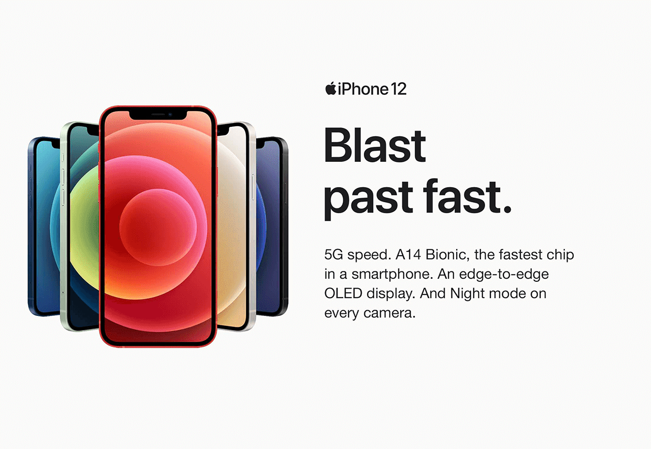**

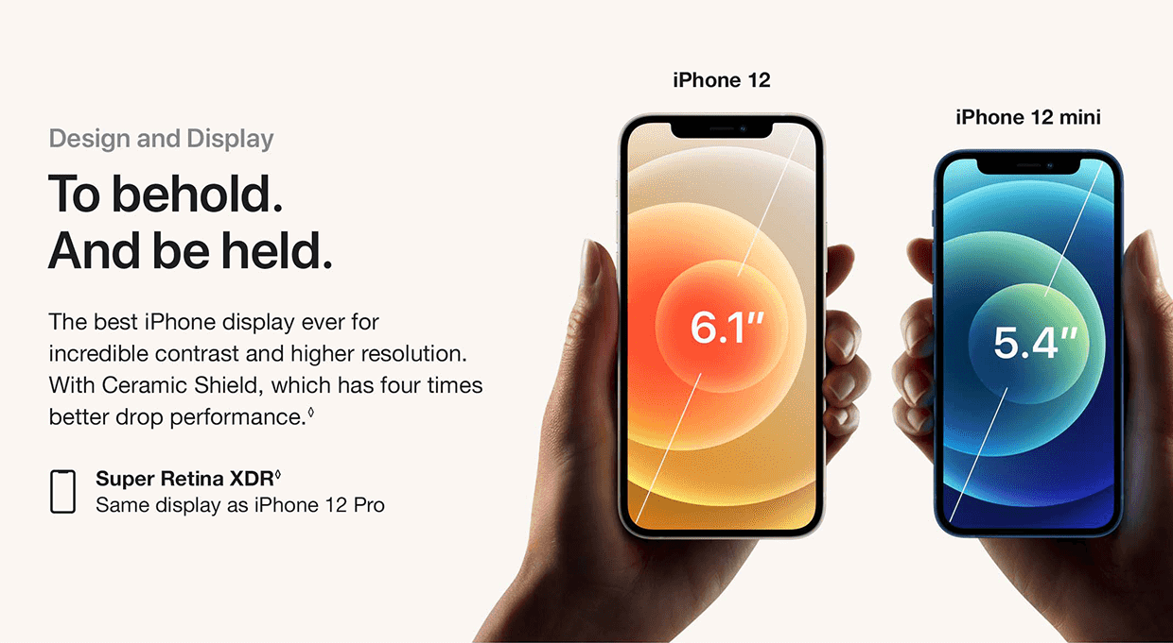

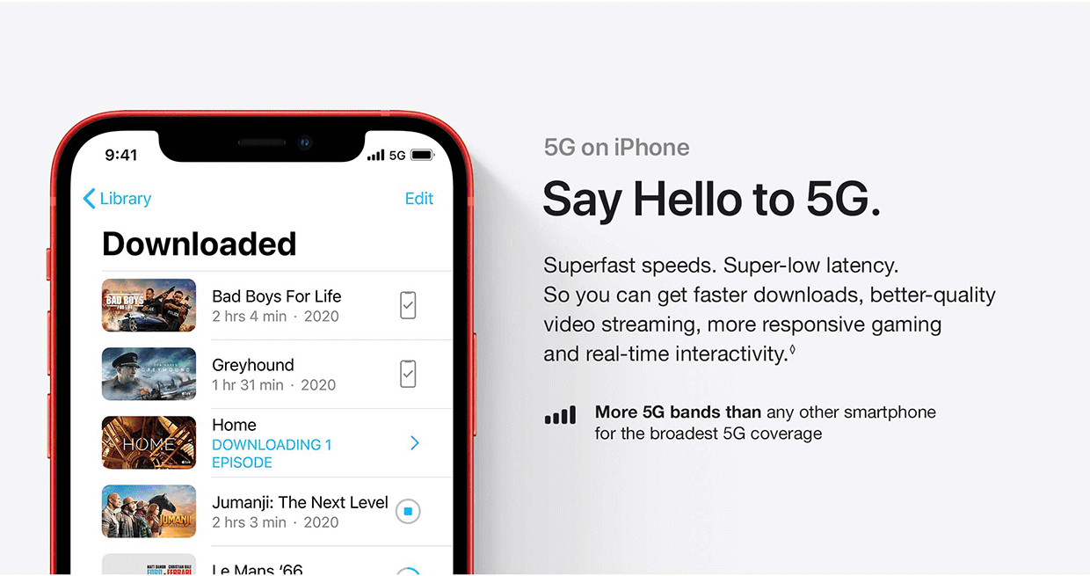

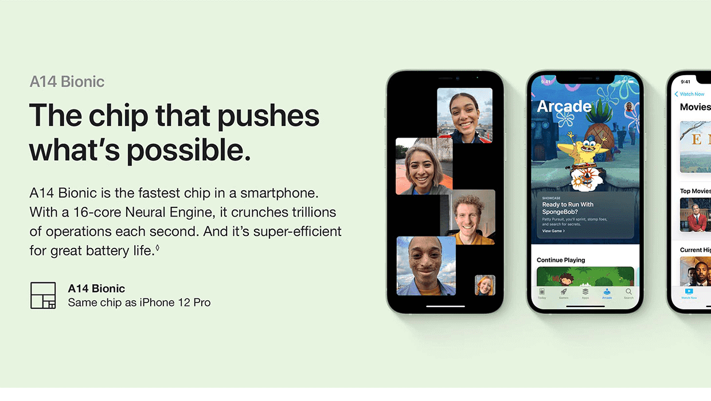

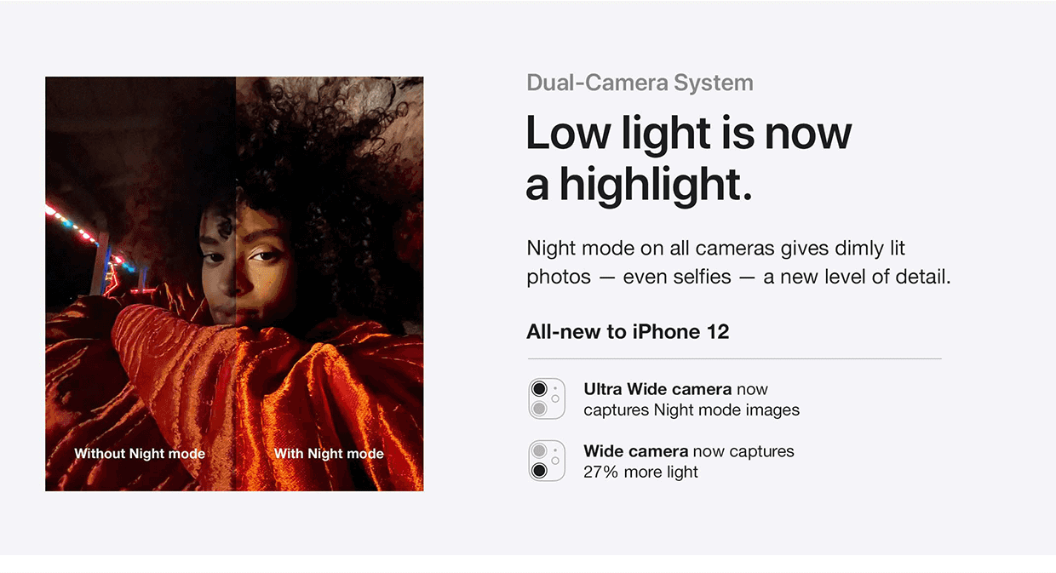

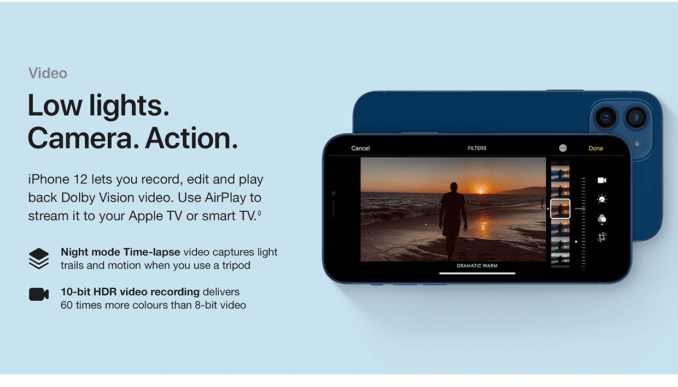

|  |  |
| --- | --- |
|  |  |
|  |  |
|  |  |
|  |  |
|  |  |
|  |  |
|  |  |
|  |  |
|  |  |
|  |  |
|  |  |
|  |  |
|  |  |
|  |  |
|  |  |
|  |  |
|  |  |
|  |  |
|  |  |
|  |  |
|  |  |
|  |  |

Top of Form













Bottom of Form

**RELATED PRODUCTS**

**Sale!**

[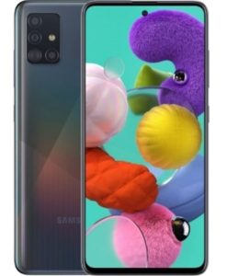](https://snapcraze.co.za/product/samsung-galaxy-a51-128gb-prism-crush-black/)

[**QUICK VIEW**](https://snapcraze.co.za/product/apple-iphone-12-64gb-blue/?sfdr_ptcid=32446_617_666085000&sfdr_hash=f536959980b3af2802ba36eb16ef628a&gclid=EAIaIQobChMI1ITI_P7p8gIVqO_tCh3ssgyMEAQYASABEgKDmfD_BwE#quick-view)

BUDGET DEVICES

[Samsung Galaxy A51 128GB Prism Crush Black](https://snapcraze.co.za/product/samsung-galaxy-a51-128gb-prism-crush-black/)

R **R5,499.00**

[**READ MORE**](https://snapcraze.co.za/product/samsung-galaxy-a51-128gb-prism-crush-black/)

**Sale!**

[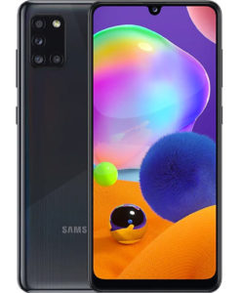](https://snapcraze.co.za/product/samsung-galaxy-a31-128gb-prism-crush-black/)

[**QUICK VIEW**](https://snapcraze.co.za/product/apple-iphone-12-64gb-blue/?sfdr_ptcid=32446_617_666085000&sfdr_hash=f536959980b3af2802ba36eb16ef628a&gclid=EAIaIQobChMI1ITI_P7p8gIVqO_tCh3ssgyMEAQYASABEgKDmfD_BwE#quick-view)

BUDGET DEVICES

[Samsung Galaxy A31 128GB Prism Crush Black](https://snapcraze.co.za/product/samsung-galaxy-a31-128gb-prism-crush-black/)

R **R4,999.00**

[**ADD TO CART**](https://snapcraze.co.za/product/apple-iphone-12-64gb-blue/?add-to-cart=49895)

**Sale!**

[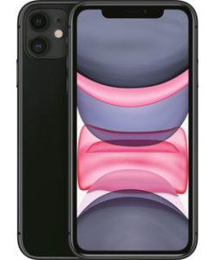](https://snapcraze.co.za/product/apple-iphone-11-64gb-black/)

[**QUICK VIEW**](https://snapcraze.co.za/product/apple-iphone-12-64gb-blue/?sfdr_ptcid=32446_617_666085000&sfdr_hash=f536959980b3af2802ba36eb16ef628a&gclid=EAIaIQobChMI1ITI_P7p8gIVqO_tCh3ssgyMEAQYASABEgKDmfD_BwE#quick-view)

APPLE

[Apple iPhone 11 64GB Black](https://snapcraze.co.za/product/apple-iphone-11-64gb-black/)

R **R13,999.00**

[**ADD TO CART**](https://snapcraze.co.za/product/apple-iphone-12-64gb-blue/?add-to-cart=37807)

**Sale!**

[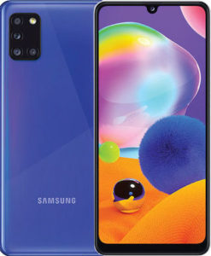](https://snapcraze.co.za/product/samsung-galaxy-a31-dual-sim-128gb-prism-crush-blue/)

[**QUICK VIEW**](https://snapcraze.co.za/product/apple-iphone-12-64gb-blue/?sfdr_ptcid=32446_617_666085000&sfdr_hash=f536959980b3af2802ba36eb16ef628a&gclid=EAIaIQobChMI1ITI_P7p8gIVqO_tCh3ssgyMEAQYASABEgKDmfD_BwE#quick-view)

BUDGET DEVICES

[Samsung Galaxy A31 (Dual Sim) 128GB Prism Crush Blue](https://snapcraze.co.za/product/samsung-galaxy-a31-dual-sim-128gb-prism-crush-blue/)

R **R6,499.00**

[**ADD TO CART**](https://snapcraze.co.za/product/apple-iphone-12-64gb-blue/?add-to-cart=51636)

**Sale!**

[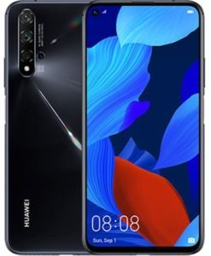](https://snapcraze.co.za/product/huawei-nova-5t-dual-sim-128gb-black/)

[**QUICK VIEW**](https://snapcraze.co.za/product/apple-iphone-12-64gb-blue/?sfdr_ptcid=32446_617_666085000&sfdr_hash=f536959980b3af2802ba36eb16ef628a&gclid=EAIaIQobChMI1ITI_P7p8gIVqO_tCh3ssgyMEAQYASABEgKDmfD_BwE#quick-view)

BUDGET DEVICES

[Huawei Nova 5T (Dual Sim) 128GB Black](https://snapcraze.co.za/product/huawei-nova-5t-dual-sim-128gb-black/)

R **R7,250.00**

[**READ MORE**](https://snapcraze.co.za/product/huawei-nova-5t-dual-sim-128gb-black/)

**Sale!**

[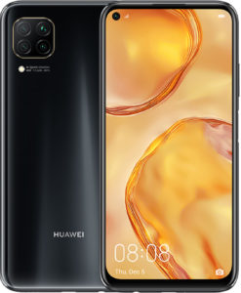](https://snapcraze.co.za/product/huawei-p40-lite-dual-sim-128gb-midnight-black/)

[**QUICK VIEW**](https://snapcraze.co.za/product/apple-iphone-12-64gb-blue/?sfdr_ptcid=32446_617_666085000&sfdr_hash=f536959980b3af2802ba36eb16ef628a&gclid=EAIaIQobChMI1ITI_P7p8gIVqO_tCh3ssgyMEAQYASABEgKDmfD_BwE#quick-view)

BUDGET DEVICES

[Huawei P40 lite (Dual Sim) 128GB Midnight Black](https://snapcraze.co.za/product/huawei-p40-lite-dual-sim-128gb-midnight-black/)

R **R5,699.00**

[**READ MORE**](https://snapcraze.co.za/product/huawei-p40-lite-dual-sim-128gb-midnight-black/)

**Sale!**

[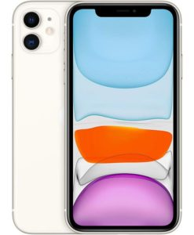](https://snapcraze.co.za/product/apple-iphone-11-256gb-white/)

[**QUICK VIEW**](https://snapcraze.co.za/product/apple-iphone-12-64gb-blue/?sfdr_ptcid=32446_617_666085000&sfdr_hash=f536959980b3af2802ba36eb16ef628a&gclid=EAIaIQobChMI1ITI_P7p8gIVqO_tCh3ssgyMEAQYASABEgKDmfD_BwE#quick-view)

APPLE

[Apple iPhone 11 256GB White](https://snapcraze.co.za/product/apple-iphone-11-256gb-white/)

R **R20,999.00**

[**READ MORE**](https://snapcraze.co.za/product/apple-iphone-11-256gb-white/)

**Sale!**

[[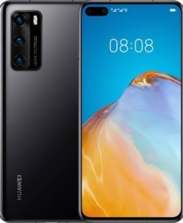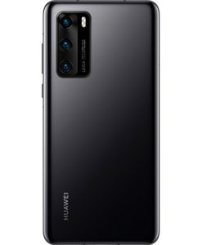](https://snapcraze.co.za/product/huawei-p40-5g-128gb-black/)](https://snapcraze.co.za/product/huawei-p40-5g-128gb-black/)

[**QUICK VIEW**](https://snapcraze.co.za/product/apple-iphone-12-64gb-blue/?sfdr_ptcid=32446_617_666085000&sfdr_hash=f536959980b3af2802ba36eb16ef628a&gclid=EAIaIQobChMI1ITI_P7p8gIVqO_tCh3ssgyMEAQYASABEgKDmfD_BwE#quick-view)

FLAGSHIP DEVICES

[Huawei P40 5G 128GB Black](https://snapcraze.co.za/product/huawei-p40-5g-128gb-black/)

R **R11,999.00**

[**ADD TO CART**](https://snapcraze.co.za/product/apple-iphone-12-64gb-blue/?add-to-cart=49062)

**Sale!**

[[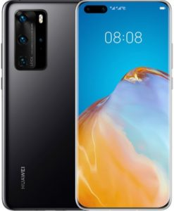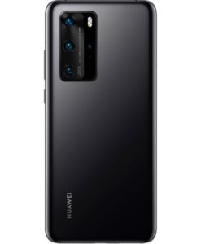](https://snapcraze.co.za/product/huawei-p40-pro-5g-256gb-black-brand-new-open-box/)](https://snapcraze.co.za/product/huawei-p40-pro-5g-256gb-black-brand-new-open-box/)

[**QUICK VIEW**](https://snapcraze.co.za/product/apple-iphone-12-64gb-blue/?sfdr_ptcid=32446_617_666085000&sfdr_hash=f536959980b3af2802ba36eb16ef628a&gclid=EAIaIQobChMI1ITI_P7p8gIVqO_tCh3ssgyMEAQYASABEgKDmfD_BwE#quick-view)

FLAGSHIP DEVICES

[Huawei P40 Pro 5G 256GB Black – Brand New Open Box](https://snapcraze.co.za/product/huawei-p40-pro-5g-256gb-black-brand-new-open-box/)

R **R13,750.00**

[**READ MORE**](https://snapcraze.co.za/product/huawei-p40-pro-5g-256gb-black-brand-new-open-box/)

**Sale!**

[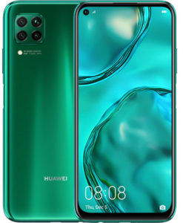](https://snapcraze.co.za/product/huawei-p40-lite-dual-sim-128gb-crush-green/)

[**QUICK VIEW**](https://snapcraze.co.za/product/apple-iphone-12-64gb-blue/?sfdr_ptcid=32446_617_666085000&sfdr_hash=f536959980b3af2802ba36eb16ef628a&gclid=EAIaIQobChMI1ITI_P7p8gIVqO_tCh3ssgyMEAQYASABEgKDmfD_BwE#quick-view)

BUDGET DEVICES

[Huawei P40 lite (Dual Sim) 128GB Crush Green](https://snapcraze.co.za/product/huawei-p40-lite-dual-sim-128gb-crush-green/)

R **R6,499.00**

[**READ MORE**](https://snapcraze.co.za/product/huawei-p40-lite-dual-sim-128gb-crush-green/)

**Sale!**

[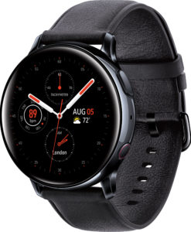](https://snapcraze.co.za/product/samsung-galaxy-watch-active-2-lte-44mm-black/)

[**QUICK VIEW**](https://snapcraze.co.za/product/apple-iphone-12-64gb-blue/?sfdr_ptcid=32446_617_666085000&sfdr_hash=f536959980b3af2802ba36eb16ef628a&gclid=EAIaIQobChMI1ITI_P7p8gIVqO_tCh3ssgyMEAQYASABEgKDmfD_BwE#quick-view)

SAMSUNG GALAXY WATCH

[Samsung Galaxy Watch Active 2 LTE 44mm – Black](https://snapcraze.co.za/product/samsung-galaxy-watch-active-2-lte-44mm-black/)

R **R7,250.00**

[**ADD TO CART**](https://snapcraze.co.za/product/apple-iphone-12-64gb-blue/?add-to-cart=52048)

**Sale!**

[](https://snapcraze.co.za/product/samsung-galaxy-a51-128gb-dual-sim-prism-crush-black/)

[**QUICK VIEW**](https://snapcraze.co.za/product/apple-iphone-12-64gb-blue/?sfdr_ptcid=32446_617_666085000&sfdr_hash=f536959980b3af2802ba36eb16ef628a&gclid=EAIaIQobChMI1ITI_P7p8gIVqO_tCh3ssgyMEAQYASABEgKDmfD_BwE#quick-view)

BUDGET DEVICES

[Samsung Galaxy A51 128GB (Dual Sim) Prism Crush Black](https://snapcraze.co.za/product/samsung-galaxy-a51-128gb-dual-sim-prism-crush-black/)

R **R7,999.00**

[**READ MORE**](https://snapcraze.co.za/product/samsung-galaxy-a51-128gb-dual-sim-prism-crush-black/)

Nationwide

**NATIONWIDE**

Delivery anywhere in South Africa

Fast Delivery

**FAST DELIVERY**

Door to Door Service

Secure Shopping

**SECURE SHOPPING**

SSL Secured

Special Offers 

**SPECIAL OFFERS**

Get the Best Specials

bg_image

Copyright 2021 © **Snapcraze**. All rights reserved | **[Terms & Conditions/Return Policy](https://snapcraze.co.za/terms)**

[](https://www.pricecheck.co.za/)